FreightShare MVP — Dev Setup & Structure

Monorepo Structure
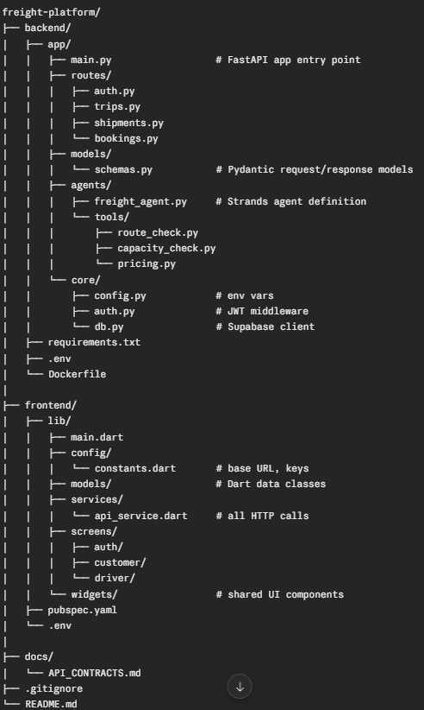
VS Code Extensions
Everyone installs
- GitLens — see who changed what, inline blame
- Git Graph — visual branch history
- Prettier — consistent formatting
- ENV — .env file syntax highlighting
- Thunder Client — test API endpoints inside VS Code (lightweight Postman alternative)
Backend devs (Dev 2, Dev 3)
- Python (Microsoft)
- Pylance
- Python Indent
- autoDocstring — generates docstrings automatically
Agent dev (Dev 1)
- Same as backend devs
- AWS Toolkit — manage Bedrock, view CloudWatch logs from VS Code
Flutter devs (Dev 4, Dev 5)
- Flutter (Dart Code team)
- Dart (Dart Code team)
- Flutter Widget Snippets
- Awesome Flutter Snippets

Running the Backend Locally
cd backend
python -m venv venv
source venv/bin/activate # Windows: venv\Scripts\activate
pip install -r requirements.txt
uvicorn app.main:app --reload --port 8000
API docs auto-generated at http://localhost:8000/docs — FastAPI gives you Swagger UI for free. Use this to test endpoints without Thunder Client.

Running Flutter Locally
cd frontend
flutter pub get
flutter run
Flutter will ask which device to run on — pick your emulator or connected phone. If no emulator is set up, install Android Studio solely to create an AVD (Android Virtual Device), then come back to VS Code.

Environment Variables
backend/.env
SUPABASE_URL=
SUPABASE_KEY=
AWS_ACCESS_KEY_ID=
AWS_SECRET_ACCESS_KEY=
AWS_REGION=ap-south-1
JWT_SECRET=
frontend/.env (use flutter_dotenv package)
BASE_URL=https://your-railway-app.up.railway.app
Never commit .env files. Add them to .gitignore on Day 1 before anyone pushes.

Git Workflow (5-person team)
One branch per person, named by role:
main
├── dev/agent
├── dev/backend-routes
├── dev/backend-db
├── dev/flutter-customer
└── dev/flutter-driver
Rules:
- Never push directly to main
- Raise a PR to merge into main, one other person reviews
- Pull from main every morning before starting work
- Commit messages: feat:, fix:, chore: prefix — keeps history readable

Deployment (Backend)
Use Railway for the backend. Free tier, deploys from GitHub directly.
Steps:
- Push backend to GitHub
- Create Railway project → connect repo → set root directory to /backend
- Add all env vars in Railway dashboard
- Railway gives you a public URL — put this in Flutter's BASE_URL
Do this on Day 1. Every Flutter dev and the agent dev needs this URL to test against real APIs instead of coordinating localhost.

Day 1 Checklist (Before Anyone Writes Features)
- [ ] Repo created, all 5 people have push access
- [ ] .gitignore includes .env, venv/, __pycache__/, .dart_tool/
- [ ] Supabase project created, schema pushed, SUPABASE_URL and SUPABASE_KEY shared
- [ ] FastAPI skeleton running with /health endpoint returning {"status": "ok"}
- [ ] Backend deployed to Railway, public URL shared in group chat
- [ ] Flutter project scaffolded, runs on at least one emulator
- [ ] AWS credentials working, Bedrock model access confirmed in ap-south-1
- [ ] docs/API_CONTRACTS.md written and committed by Dev 2
- [ ] All 5 devs have cloned the repo and can run their respective parts

requirements.txt (Backend)
fastapi
uvicorn[standard]
pydantic
python-dotenv
supabase
python-jose[cryptography]
passlib[bcrypt]
strands-agents
boto3
httpx

pubspec.yaml (Flutter — key dependencies)
dependencies:
flutter:
sdk: flutter
http: ^1.2.0
flutter_dotenv: ^5.1.0
flutter_secure_storage: ^9.0.0
google_maps_flutter: ^2.5.0
provider: ^6.1.0

